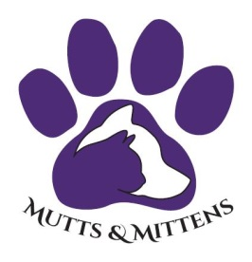
105 Shady Creek Ct, Weatherford, TX 76087
Phone: 817-454-5293
PUTTS FOR MUTTS SPONSORSHIP FORM
 | Sponsorship Name:
 | Contact Name:
 | Email:
 | Phone#:
 | Address:
 | City: |  |  | State: |  | Zip Code:
Please select sponsorship level:
Title Sponsor - $2,500 (2 available)
Towel Sponsor - $1,500 (1 available)
Cap Sponsor - $1,500 (1 available)
Scorecard Sponsor - $1,000 (1 available)
Pin Flag Sponsor - $1,000 (1 available)
Dinner Sponsor - $1,000 (1 available)
Cart Sponsor - $750 (1 available)
Golf Ball Sponsor - $750 (1 available)
Koozie Sponsor - $750 (1 available)
Buy Up Hole Sponsor - $500 (1 available)
Mulligan Card Sponsor - $500 (1 available)
Beverage Cart Sponsor - $250 (2 available)
Closest to the Pin Sponsor - $150 (1 available)
Putting Green Sponsor - $150 (1 available)
Driving Range Sponsor - $150 (1 available)
Longest Drive Sponsor - $150 (1 available)
Hole Sponsor - $100 (unlimited available)
Select Payment Method:
Credit Cards accepted via PayPal to donate@muttsandmittens.org
Check – Mail to Mutts & Mittens at 105 Shady Creek Ct, Weatherford, TX 76087

Return Form with Logo/Picture to:
kim@muttsandmittens.org
Mutts & Mittens at 105 Shady Creek Ct, Weatherford, TX 76087
Signature: |  | Date Signed:
Mutts & Mittens is a 501(c)3 non-profit organization. Tax ID# 81-2253955

